Onboarding a New vEdge

By Don Chen

# Description

We are onboarding a new office, the vEdge device has already arrived. We need to onboard it so that we can manage it using our SD-WAN network.

# Requirements

* Physical access to the new vEdge.
* Remote access to the vManage.
* Remote access to the vBond
* Remote access to the vSmart

# Step-by-Step Instructions

1. Plug into the console port.
2. Using a terminal emulation program, like PuTTY, access the CLI of the vEdge.
3. Log in with the default credentials: admin/admin. If it asks you to set a new password, set it to a new password.
4. Paste the following command into the CLI:

config

system

system-ip 172.16.1.1

site-id 2

organization-name seaice

vbond 10.1.0.2

exit

vpn 0

ip route 10.1.0.0/24 10.50.0.1

ip route 10.1.0.0/24 10.50.0.5 20

interface ge0/0

ip address 10.50.0.2/30

tunnel-interface

encapsulation ipsec

color biz-internet

allow-service all

no shutdown

exit

exit

interface ge0/1

ip address 10.50.0.6/30

tunnel-interface

encapsulation ipsec

color public-internet

allow-service all

no shutdown

exit

exit

commit

end

1. Download the root CA cert from vManage by pasting the following command: request download scp://admin@10.1.0.3:/home/admin/ROOT-CA.pem
2. It will ask you if you want to continue, type yes. It will prompt for the password to vManage, type in the password.
3. Install the root certificate by pasting this: request root-cert-chain install /home/admin/ROOT-CA.pem
4. Create a CSR for the vEdge by pasting this: request csr upload home/admin/vedge1_csr
5. When prompted for the organization name, use: seaice
6. Remote into the vManage CLI. Type in the username and password.
7. Enter into the Linux CLI of vManage by pasting: vshell
8. Download the CSR from the new vEdge by pasting this command including the period at the end: scp admin@10.50.0.2:/home/admin/vedge1_csr .
9. When prompted, type in the password for the new vEdge.
10. Sign the certificate by pasting this command 1 line at a time:

openssl x509 -req -in vedge1_csr \

-CA ROOT-CA.pem -CAkey ROOT-CA.key -CAcreateserial \

-out vedge1.crt -days 2000 -sha256

1. Go back to the vEdge CLI.
2. Download the certificate by pasting: request download scp://admin@10.1.0.1:/home/admin/vedge1.crt
3. When prompted for the password, type in the password of the vManage.
4. Install the certificate by pasting: request certificate install home/admin/vedge1.crt
5. Copy the chassis and serial number of the vEdge from pasting in this command: show certificate serial
6. Remote into vManage.
7. Paste this command, replacing the bracketed info with the chassis and serial number from earlier: request vedge add chassis-num <chassis number> serial-num <serial number>
8. Remote into vBond, log in.
9. Paste this command, replacing the bracketed info with the chassis and serial number from earlier: request vedge add chassis-num <chassis number> serial-num <serial number>
10. Remote into the vManage GUI and log in.
11. Navigate to Configuration -> Certificates -> WAN Edge List. Then click on send to controllers. It will look similar to the picture below.

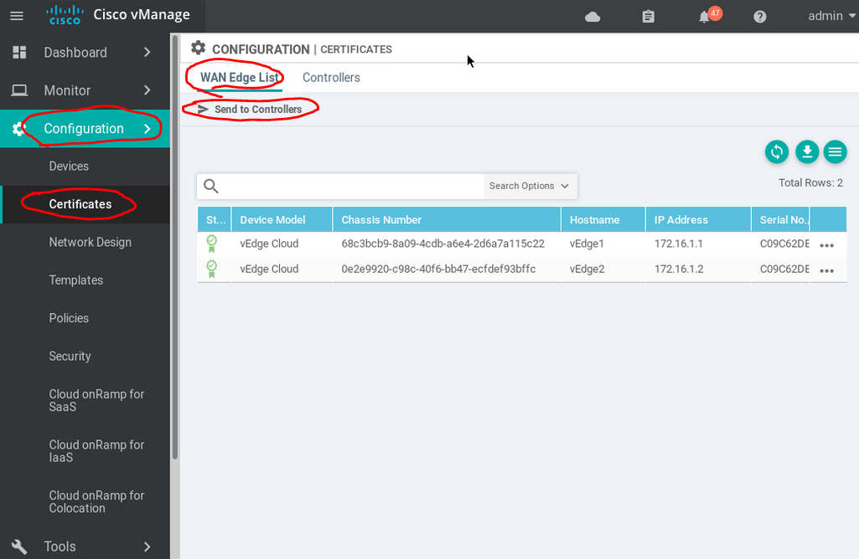

1. Wait for the success messages.

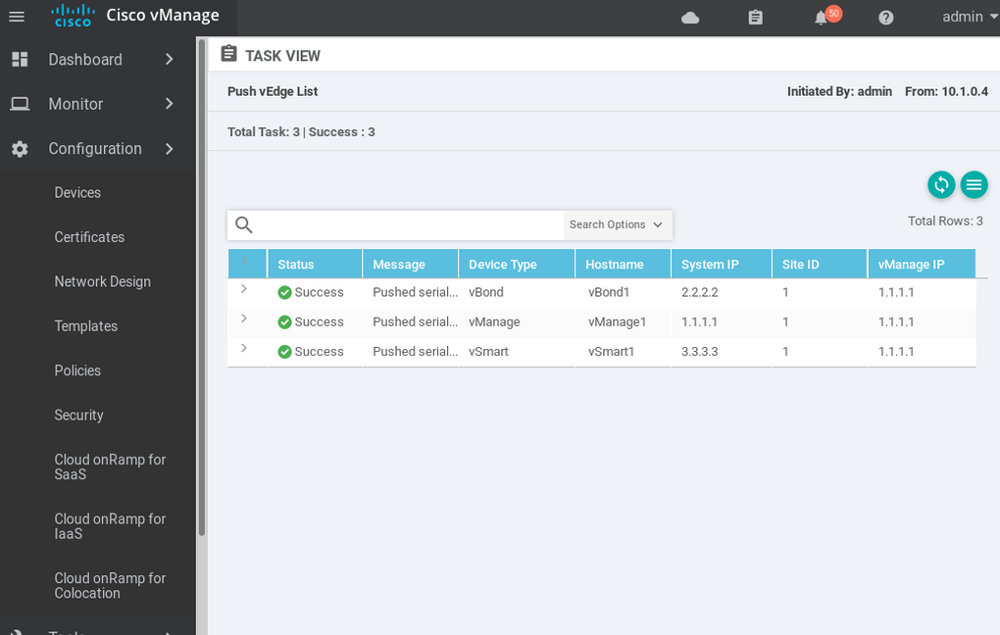

# Verification

1. Access the CLI of the vEdge and log in.
2. Ping the vSmart (10.1.0.1), vBond (10.1.0.2), and vManage (10.1.0.3).
3. Access the CLI of vSmart and log in.
4. Paste in: show omp peers
5. Look for the new peer at 172.16.1.1. It will look similar to the image below.

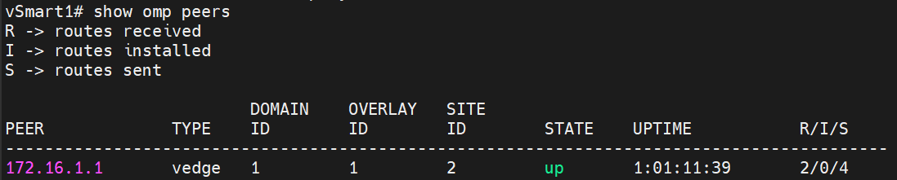

# Backout Plan

1. Access the CLI of the vEdge and log in.
2. Paste in this command to reset the configurations: request reset configuration
3. When prompted to confirm, type yes.